NAME: ADM No:
CLASS: SIGN:
232
PYSICS FORM 1
END TERM 2 YEAR
AUG/SEP 2022
TIME 2 HRS

INSTRUCTIONS
i) Answer All questions in the spaces provided.
ii) Use the following CONSTANTS where applicable.
iii) All working must be clearly shown for numerical questions.
iv) Candidates should check to ascertain that all questions and pages are available.
Constants
i) Density of water = 1g/cm3 or 1000kg/m³.
ii) Gravitational acceleration = 10m/s².

SECTION A (40 MARKS)
- a). Name three branches of physics (3mks)

b). Explain how biology is related to physics. (2mks)

c). Kamau a form one student visited the lab to conduct an experiment in electricity, state two observation he is to observe before doing the connections. (2mks)

- The table below shows the basic physical quantities in physics. fill in the blank spaces. (3mks)
Basic physical quantity | SI unit | Symbol of unit
length | metre
Electric current |  | A
 | candela | Cd

- Define force and state its SI unit (2mks)

- Name two forces acting on a cork floating on water. (2mks)

- Two identical spring balances A and B each weighing 0.8N are arranged as shown below.
What are the readings of A and B? (2mks)
A
B
30N

- a) The diagram below shows water drops being placed slowly on two surfaces.

clean glass waxed surface
Draw the two surfaces with water drops on them. (2mks)
b). Explain the appearance of the drop on the two surfaces. (2mks)

- a) State three differences between mass and weight. (3mks)

b). A mass of 7.5kg has weight of 30N on a certain planet. Calculate the acceleration due to gravity on this planet. (2mks)

- a) What is matter. (1mk)

b) Name two pieces of evidence which shows that particles of matter move. (2mks)

- List down three states of matter. (3mks)

- With an aid of diagram describe an experiment that you would use to show that matter is made up of tiny particles. (3mks)

- a) When the stopper is removed from a bottle containing liquid ammonia, the ammonia can be smelled in all parts of the room after a short while. Explain this observation. (2mks)

b) State two factors that affect the rate of diffusion in gases. (2mks)

- a) Explain the meaning of the term electrostatic. (1mk)

b) state the basic law of electrostatic. (1mk)

SECTION B (60 MARKS)
- a) Draw a well labeled diagram of a clinical thermometer. (3mks)

b) Give a reason why clinical thermometer cannot be sterilized using boiling water. (1mk)

c). State two features of liquid in glass thermometer that makes it sensitive. (2mks)

d) . Give three reasons why water is not suitable as thermometric liquid. (3mks)

e). Convert the following into units in the brackets.
I) 20⁰c (K) (2mks)

II) 180K (⁰c) (2mks)

- a) Define the term pressure and state its SI unit. (2mks)

b) What property of mercury makes it suitable for use in a barometer. (1mk)

c). In an experiment to demonstrate atmospheric pressure, a plastic bottle was partially filled with hot water and the bottle is tightly corked. After sometime the bottle started to get deformed.
i) state the purpose of the hot water. (1mk)

ii). Explain why the bottle got deformed. (2mks)

d). The diagram below shows a mercury barometer.
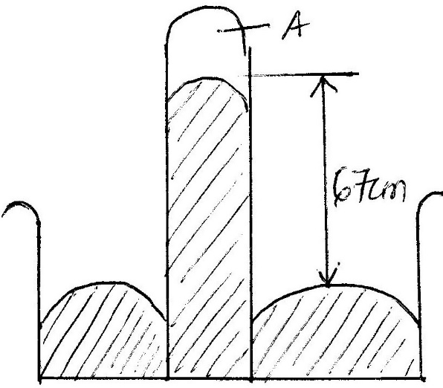
- Name the part labeled A (1mk)

ii) Calculate the atmospheric pressure of the place in;
I). mmHg (1mk

II). Pascals given the density of mercury is 13600Kg/m3 (3mks)

d). State two advantages of a force pump over lift pump. (2 marks)

- a) Define volume and state its SI unit (2mks)

b). The figure below shows a measuring cylinder which contains water initially at level A. when a solid of mass 10g is immersed in water the level raises to B.
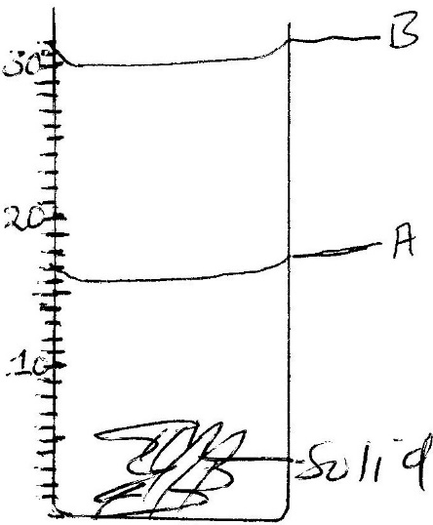

Determine;
- the volume of the solid. (2mks)

- the density of the solid (3mks)

c) In an experiment to estimate the height of a tree in a school compound, a form one student recorded the following data;
Length of the shadow of the tree =900cm
Length of shadow of the rod = 300cm.
Height of the rod = 150cm
Determine the height of the tree in SI unit. (3mks)

d)The diameter of a hydrogen atom is 0.00000008cm. express this diameter in SI unit in standard form. (2mks)

- a) State two laws of reflection light. (2mks)

b) The diagram below shows a ray of light incident on a plane mirror.
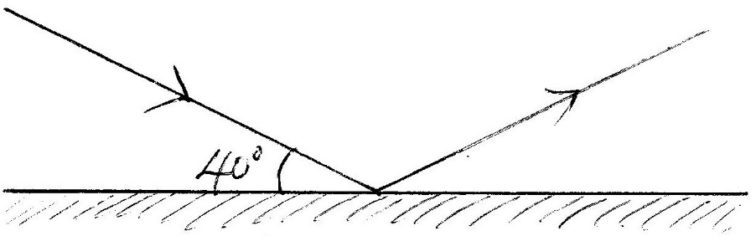
Find the angle of reflection. (2mks)

c). A student placed two plane mirrors at an angle X to each other and counted seven images of an object placed between the mirrors determine the angles between mirrors. (3mks)

d) A pinhole camera forms an image of a flag post 30m in front of the pinhole. If the height of the image is 10 cm and the screen is 20cm behind the pinhole, determine the height of the flag post. (3mk)

e) State two differences between the image formed by plane mirror and pinhole camera. (2mks)

- a) State three factors that affect heat conductivity in solid. (3mks)

b) Two copper rods A and B of the same length are attached with candle wax to either end and placed on a wooden blocks equidistant from the source of heat as shown below.
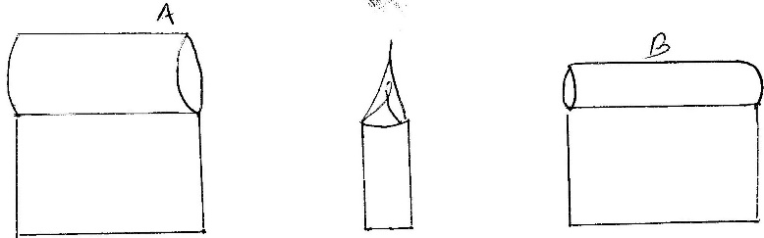
- Which wax will melt first? (1mk)

- give a reason for your answer in (i) above. (1mk)

- Figure 8 shows a cross section of a vacuum flask
Fig.8
B
A
Cork
Support

(a) (i) Name the parts labelled A and B (2mks)
A …………………………………………………………………………..
B …………………………………………………………………………..
(ii) Explain how the heat losses are minimized when hot liquid is poured into the flask (3mks)

