NAME: ADM NO:

DATE: SIGN:

312/1
GEOGRAPHY
FORM I
END OF TERM II EXAM (2022)
TIME: 2 HRS

Instructions
- Answer all questions on the spaces provided
- Answer should be written in English

Answer all the questions in the spaces provided
1 (a) Name two Greek words from which the term geography originated (2mks) …………………………………………………………………………………………………………………………………………………………
…………………………………………………………………………………………………………………………………………………………
b) What is environment? (2mks)
…………………………………………………………………………………………………………………………………………………………
…………………………………………………………………………………………………………………………………………………………
c) List four main areas covered in human geography (4mks)
…………………………………………………………………………………………………………………………………………………………
…………………………………………………………………………………………………………………………………………………………
…………………………………………………………………………………………………………………………………………………………
…………………………………………………………………………………………………………………………………………………………
d) Explain the relationship between geography and the following subjects
i) Biology (2mks)
…………………………………………………………………………………………………………………………………………………………
…………………………………………………………………………………………………………………………………………………………
(ii) Agriculture (2mks)
…………………………………………………………………………………………………………………………………………………………
…………………………………………………………………………………………………………………………………………………………
2(a) Explain the meaning of the following terms
(i) Weather (2mks)
…………………………………………………………………………………………………………………………………………………………
…………………………………………………………………………………………………………………………………………………………
(ii) A weather station (2mks)
…………………………………………………………………………………………………………………………………………………………
…………………………………………………………………………………………………………………………………………………………
B (i) Your school want to establish a weather station, name the area within the compound where it can be sited (1mk)
…………………………………………………………………………………………………………………………………………………………
(ii) State four factors that the school would consider while establishing the weather station (4mks)
…………………………………………………………………………………………………………………………………………………………
…………………………………………………………………………………………………………………………………………………………
…………………………………………………………………………………………………………………………………………………………
…………………………………………………………………………………………………………………………………………………………
3 (a) Apart from convectional rainfall, name two other types of rainfall. (2mks)
…………………………………………………………………………………………………………………………………………………………
…………………………………………………………………………………………………………………………………………………………

b (i) While using a well labeled diagram, describe how convectional rainfall is formed (9mks)

ii) State three characteristics of convectional rainfall (3mks)
…………………………………………………………………………………………………………………………………………………………
…………………………………………………………………………………………………………………………………………………………
…………………………………………………………………………………………………………………………………………………………
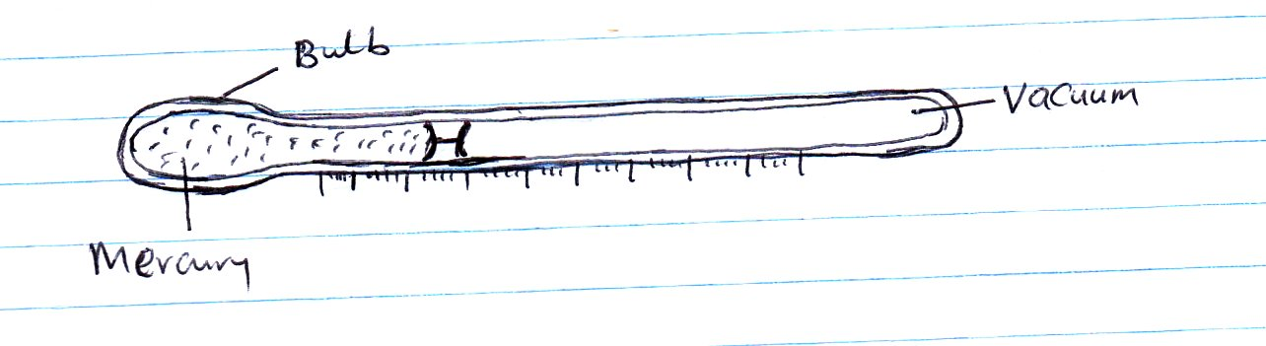
4(a) Study the diagram below representing an instrument for measuring on element of weather. Use it to answer question i, and ii.

(i) Which element of weather is measured using the above instrument? (1mk)
…………………………………………………………………………………………………………………………………………………………
(ii) Describe how the above instrument is used to measure the element given in 4 a (i) above (4mks)
…………………………………………………………………………………………………………………………………………………………
…………………………………………………………………………………………………………………………………………………………
…………………………………………………………………………………………………………………………………………………………
…………………………………………………………………………………………………………………………………………………………
(b) Apart from the above instrument, name three other instruments found in a Stevenson Screen (3mks)
…………………………………………………………………………………………………………………………………………………………
…………………………………………………………………………………………………………………………………………………………
…………………………………………………………………………………………………………………………………………………………
(5) The table below shows rainfall and temperature figures for a station in Kenya. Use it to answer question i, ii, iii and iv.
Month | J | F | M | A | M | J | J | A | S | O | N | D
Temp ⁰c | 27 | 25 | 23 | 20 | 18 | 18 | 17 | 19 | 20 | 21 | 21 | 24
Rainfall (Mm) | 53 | 50 | 55 | 251 | 242 | 230 | 180 | 109 | 90 | 51 | 85 | 100
(i) Calculate the diurnal range of temperature for the station (2mks)
…………………………………………………………………………………………………………………………………………………………
…………………………………………………………………………………………………………………………………………………………
(ii) Calculate the average temperature for the station (2mks)
…………………………………………………………………………………………………………………………………………………………
…………………………………………………………………………………………………………………………………………………………
(iii) Determine the total annual rainfall (2mks)
…………………………………………………………………………………………………………………………………………………………
…………………………………………………………………………………………………………………………………………………………
(iv) Which month recorded the highest amount of rainfall (1mk)
…………………………………………………………………………………………………………………………………………………………
6) The diagram below shows, the external layers of the Earth’s atmosphere. Use to answer questions i, ii, and iii
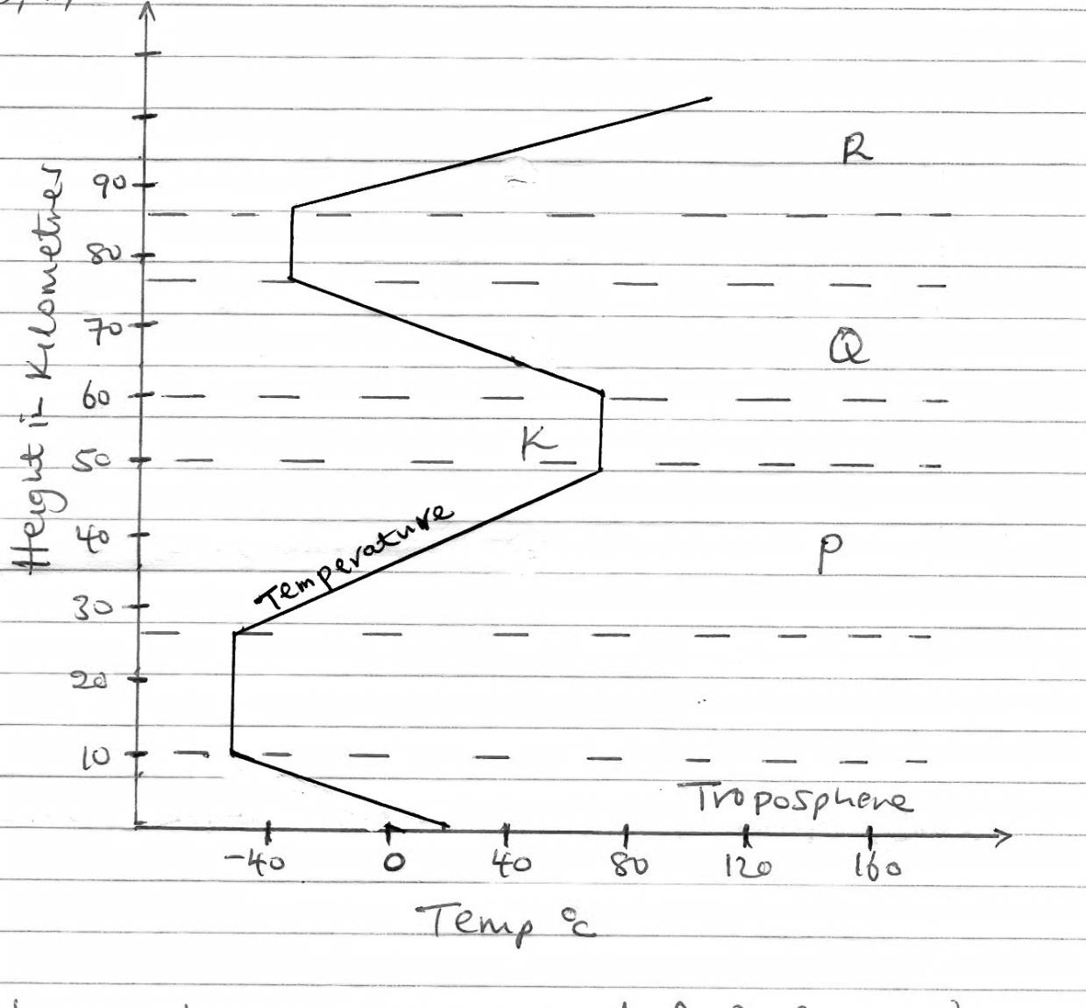

i) Name the parts marked P, Q, R (3mks)
R ………………………………
Q ………………………………
R ………………………………
ii) Identify the discontinuity labeled K (1mk)
…………………………………………………………………………………………………………………………………………………………
…………………………………………………………………………………………………………………………………………………………
…………………………………………………………………………………………………………………………………………………………
iii) Give the characteristics of the zone named Troposphere (3mks)
…………………………………………………………………………………………………………………………………………………………
…………………………………………………………………………………………………………………………………………………………
…………………………………………………………………………………………………………………………………………………………
7)a) Define the following terms
i) A picture (2mks)
…………………………………………………………………………………………………………………………………………………………
…………………………………………………………………………………………………………………………………………………………
ii)A plan (2mks)
…………………………………………………………………………………………………………………………………………………………
…………………………………………………………………………………………………………………………………………………………
iii) A map (2mks)
…………………………………………………………………………………………………………………………………………………………
…………………………………………………………………………………………………………………………………………………………
b) List three main types of maps (3mks)
…………………………………………………………………………………………………………………………………………………………
…………………………………………………………………………………………………………………………………………………………
…………………………………………………………………………………………………………………………………………………………
c) Outline five marginal information that you may get on a map (5mks)
…………………………………………………………………………………………………………………………………………………………
…………………………………………………………………………………………………………………………………………………………
…………………………………………………………………………………………………………………………………………………………
…………………………………………………………………………………………………………………………………………………………
…………………………………………………………………………………………………………………………………………………………
…………………………………………………………………………………………………………………………………………………………
…………………………………………………………………………………………………………………………………………………………
…………………………………………………………………………………………………………………………………………………………
…………………………………………………………………………………………………………………………………………………………

(d) Covert the following representative fraction into statement scale
(i) 1/200,000 (2mks)

(ii) 1/350,000 (2mks)

8 (a) List three planets that do not have satellites (3mks)
…………………………………………………………………………………………………………………………………………………………
…………………………………………………………………………………………………………………………………………………………
…………………………………………………………………………………………………………………………………………………………
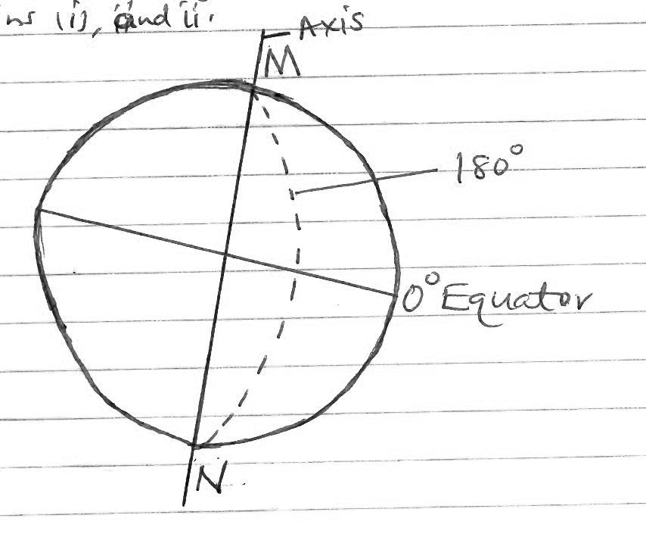
(b) Study the diagram of the earth below and we use it to answer questions i) and ii)

i) Name the parts marked M and N
M ……………………………………… (1mk)
N ………………………………………. (1mk)
ii) What is the name of the line of longitude marked 180⁰? (1mk)
…………………………………………………………………………………………………………………………………………………………
iii) What happens to time when you cross this line mentioned in b (ii) above (2mks)
…………………………………………………………………………………………………………………………………………………………
…………………………………………………………………………………………………………………………………………………………
c) What two times of the year is the sun overhead at the equator (2mks)
…………………………………………………………………………………………………………………………………………………………
…………………………………………………………………………………………………………………………………………………………
d) The time in Bangkok Thailand 100⁰E is 3:12p.m, what will be the time in Nairobi 37⁰E? (3mks)
…………………………………………………………………………………………………………………………………………………………
…………………………………………………………………………………………………………………………………………………………
…………………………………………………………………………………………………………………………………………………………
e) State four characteristics of planets (4mks)
…………………………………………………………………………………………………………………………………………………………
…………………………………………………………………………………………………………………………………………………………
…………………………………………………………………………………………………………………………………………………………
…………………………………………………………………………………………………………………………………………………………
…………………………………………………………………………………………………………………………………………………………
9 (a) Define the term statistics (2mks)
…………………………………………………………………………………………………………………………………………………………
…………………………………………………………………………………………………………………………………………………………
b) Differentiate between discrete and continuous data (2mks)
…………………………………………………………………………………………………………………………………………………………
…………………………………………………………………………………………………………………………………………………………
c) List four methods of data collection from the field (4mks)
…………………………………………………………………………………………………………………………………………………………
…………………………………………………………………………………………………………………………………………………………
…………………………………………………………………………………………………………………………………………………………
…………………………………………………………………………………………………………………………………………………………

