NAME_____________________________ADMISSION NO.__________CLASS________

231
BIOLOGY (Theory)
AUG/SEP 2022
2$\frac{1}{2}$ Hours
KENYA CERTIFICATE OF SECONDARY EDUCATION
FORM ONE BIOLOGY PAPER
MARKING SCHEME
SECTION A
1.State the use of the Pooter in the study of living organisms (1 mark)
Sucking small insects/ animals from rocks, bark of trees

2.When are two organisms considered to belong to the same species (1 mark)
When they are capable of naturally interbreeding to produce a viable / fertile offspring
3. Define the following term
- Entomology [1 mk]
Entomology: study of insects;
- Genetics [1 mk]
Genetics: study of inheritance and variation;

4. The scientific names of three animals leopard, wolf and lion in the family carnivora are; Panthera pardus, Canis lupas and Panthera leo respectively.
a) Why are scientific names given in Latin? (1 mark)

Latin language is fairly static/it does not change with time or locality like most other languages;

b) What does Canis refer to? (1 mark)

Generic name of wolf; Rej. Genus name

c) Giving a reason, state the organisms that are MOST closely related. (1 mark)

Lion and leopard, they belong to the same genus Panthera;

5. State the specific sites in which the following reactions occur: (2mks)
(i) Light stage.
- Grana/granum/thylakoid/membrane of chloroplast;
(ii) Dark stage.
Stroma (of chloroplasts ;)
6. State two functions of cell membrane (2mks)
- Covers and protects the internal structures of the cell;
- It selectively allow movement of substances in and out of the cell; (Rj: without selectively)

7(a) Explain the term cell specialization. (1mk)
Phenomenon of a cell having a structure(s) or chemical composition that enables it to perform specific/special function(s);.
(b) State how each of the cells listed is below specialized to carry out its function;
(i) Palisade cell. (1mk)
has numerous chloroplasts for photosynthesis;
(ii) A sperm cell. (1mk)
has long tail which propel the egg towards the ovum;
Has acrosome containing lytic enzyme to digest egg membrane;
Has large nucleus full of DNA/chromatin material which contain genetic material;
Has numerous mitochondria provide energy needed as it move towards the ovum;
8. Give one structural and one functional difference between smooth endoplasmic reticulum and rough endoplasmic reticulum (2 mks)
RER SER
1. Transports proteins 1. Transport lipids
2. Has ribosomes 2. Has no ribosomes
9.Name the parts of a light microscope which perform each of the following functions.
i. Controlling the amount of light entering the specimen. (lmk)
Diaphragm
ii. Magnifies the object. (1mk)
Eye piece objective lens;
iii. Used for focusing image under low power. (lmk)
Coarse adjustment knob;
10. The diagram below shows a type of epithelial tissue.

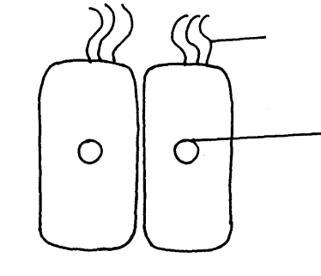
M
N

- Name the parts labelled M and N. (2mks)
M- cilia;
N – nucleus;
b. State function of structures labelled M. (lmk)
move foreign materials over the epithelium;
c. Name one part of the body where M can be found. (lmk)
trachea / oviduct
11. Give two functions of a cell membrane. (2mks)
Encloses cell content
Allow selective movement of materials in and out of the cell
12. (a) What is the formula for calculating linear magnification using a light microscope. (1mk)
Magnification = eye piece lens magnification x objective lens magnification
b) State two functions of centrioles (2 marks)
take part in Cell division; /formation of spindle fibres during cell division
- Formation of cilia and flagella;
13.(a)Name two raw materials for the dark stage process of photosynthesis. (2 marks)

Carbon (IV) oxide, hydrogen ions / atoms

- The set up shows an experiment to investigate photosynthesis.
Aquatic plants
Gas collected
At the start
After the experiment
Water containing sodium hydrogen carbonate

(1) What gas was collected in the test tube? (1 mark)
Oxygen gas
(ii)What was the role of sodium hydrogen carbonate in the experiment? (2 marks)
dissociate in water to provide carbon (IV) oxide; which is necessary for photosynthesis;

14.a) The diagram below represents a cell organelle.
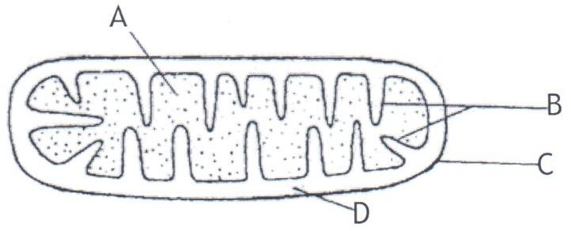
    - Identify the organelle. (1mk)
Mitochondrion rej. mitochondria.

    - Name the part labelled B. (1mk)

Cristae;
iii)State the function of the part labelled A. (1mk)

Site where respiration occur; (habours respiratory enzymes);
b)state the functions of the following parts of light microscope

(i)Condenser (1mk)

Concentrate light onto the stage/specimen
(ii)Diaphragm (1mk)
Regulate the amount of light passing through the condenser

15. State the characteristics of living things that is being demonstrated by plants
producing oxygen during daytime (1 mark)
nutrition/gaseous exchange;

16. Why is it necessary to expand biology to include the study of non living things?(1 mark)
Because living things interact with non living things in their physical environment
17.Give one importance of each of the following processes in living organisms. (3 mks)
(a) Locomotion:
Enables organisms search for food, shelter and mates; escape from predators & harsh environment.
(b) Excretion:
Helps remove waste products of metabolism from the body which may be toxic.
(c) Irritability:
Enables organisms to adjust to the changing environmental conditions.

18. Give a reason for the following.
- A mature plant cell does not collapse even after losing water. (2mks)
Plant cell is enclosed by cellulose; cell wall which is rigid;

- Explain what would happen to red blood cells if they are placed in a concentrated salt solution.
Lose water to the salt solution by osmosis; and become crenated; (2mks)
19.Distinguish between plasmolysis and Haemolysis. (2mks)
Plasmolysis – condition where a plant cell losses water and shrinks becomes flaccid .
Haemolysis - Condition where red blood cells gain water, swells and bursts.
(Both definitions must be correct.)

20. A student collected a bone from the school garden. The bone was measuring 45 cm. He drew the bone in his book and his diagram was 9 cm long.
Calculate the magnification of his drawing. (2 marks)
. Linear magnification = Length of drawing
Length of object ;
= 9 cm
45 cm
= 1
5
= X 0.2 ;

21. Name the tissue that carry out the following functions in mammals.
a) Binds and supports various organs in the body. (1 mark)

Connective tissue ;
b) Transport oxygen throughout the body. (1 mark)

Blood tissue
c)Contract and relax to bring about movement. (1 mark
Skeletal muscle tissue ;

SECTION B

22.a)Define the term cell physiology (1mk)
Is the study of the functions of cell structures / the process in which cells work
b) Two pieces of leaf petioles were cut as shown in the diagram below, then each
piece placed in solution of different concentration.
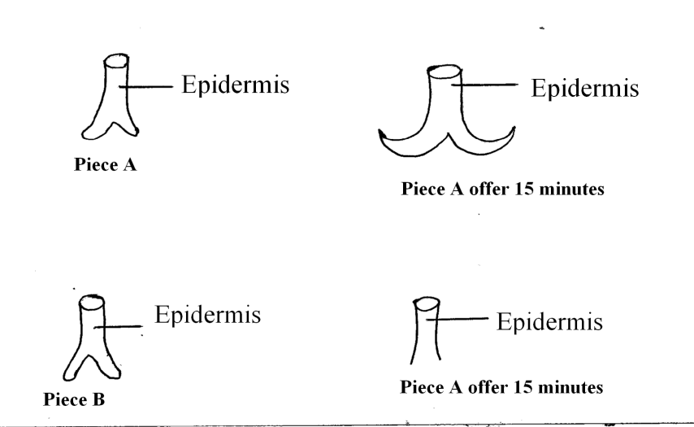
i)What physiological process was being investigated in this experiment? (1mk)
Osmosis
ii)Suggest the type of solution piece B was placed (1mk)
Hypertonic / solution more concentrated with solute

iii) Explain the appearance of piece A after 15 minutes (3mks)
Inner cells / Cut surface absorbed water fast by Osmosis become swollen / turgid faster than the outer epidermis cell the inner cells enlogate hence curving outwards. (3mks)

24. (a) Name two types of slides: (2 mks)
Permanent and Temporary
- When estimating the size of an onion epidermal cell, a transparent ruler was placed on the field of view of a light microscope and the number of mm marks counted as shown below.
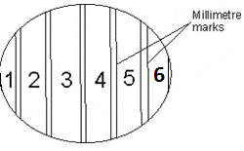

The transparent rule was then measured and replaced with a section of an onion epidermis on the field of view as shown below.
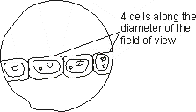

- Using the information provided above, calculate the average size of an onion epidermal cell
(3mks)
Diameter of field of view = 6000mm
Size of one cell = 5000 mm
4
= 1500mm

(ii) State one limitation of the method above for illustrating cell size (1mk)
- Cell are not equal in size / results may be affected by the turgidity of cells.difficult to estimate the size of a portion of a cell that is less than a millimeter

(c) Explain why, (i) A chop of water was placed on the epidermis before a coverslip was placed on top. (1mk)
To make the cells turgid and for clear visibility / more visible.
- A sharp surgical blade was used when cutting the epidermal sections: (1mk)
to avoid damaging / distorting sections / cell.

25.The diagram below shows an experiment to investigate the diffusion of substances through a membrane.
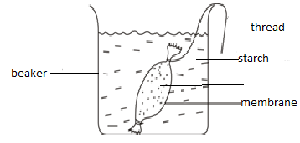
- Account for the observations made at the end of the experiment.4mks)
The starch solution turned blue black and iodine solution retains the brown colour of iodine;iodine molecules are small in size hence diffused; across the visking tubing and reacted with starch solution ;starch molecules are large hence did not diffuse out of the visking tubing;
- State two uses of osmosis in plants.(2mks)
Absorption of water from the soil;
Support in herbaceous plants;
Feeding in insectivorous plants;
Opening and closing of the stomata;
- Name two body regions in man where active transport occurs.(2mks)
Kidney tubules;
Alimentary canal;

26. A health plant was kept in the dark for 48 hrs .Then one of its leaves (x) was enclosed in a glass flask as down below .The whole plant was then returned to light
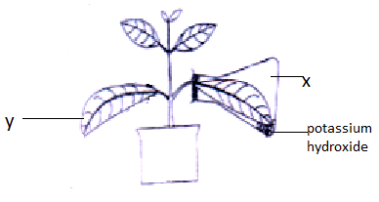

- After 48 hrs the leaves were tested for starch .What observations do you expect.(2marks)

x-took the color of iodine;
y-turn blue black;

- i) What conclusions can you draw from this observation (1mark )

starch was present in leaf y but absent in leaf x;

ii) Explain your conclusion in b (i) above (2marks)

No photosynthesis occurred in x due to lack of carbon (iv) oxide
Photosynthesis occurred in y due to presence of carbon (iv) oxide;
- Why was the plant kept in the dark for 48 hrs (1mark)
To destarched the leaf /ensure all starch was used up

SECTION C

27.a)Define the following terms (3mk)
i) Photosynthesis
manufacture of food substances using light energy
ii)Chemosynthesis
manufacture of food using energy derived from chemical reactions
iii) Nutrition
Process by which living organism obtain and ultilise nutrients
b) How is the structure of leaf adapted to the photosynthetic function? (8mks)
Broad flat lamina to increase surface area for absorption of light and carbon (IV) oxide;
Thinness of leaf to reduce distance moved by light and carbon (IV) oxide to reach photosynthetic tissue;
Presence of stomata through which carbon (IV) oxide enters the leaf;
Has transparent epidermis and cuticle that allow light to pass and reach the photosynthetic tissue;
Palisade cells have numerous chloroplasts containing chlorophyll to trap light energy;
Palisade cells located beneath upper epidermis to enable them receive maximum sunlight;
Have extensive veins to transport water and mineral salts to the photosynthetic tissue and carry away products of photosynthesis;
Have large intercellular air spaces in Spongy mesophyll for rapid diffusion of carbon (IV) oxide to palisade cells and oxygen out of the leaf;

c) Describe the light stage of photosynthesis (9mks)
Chlorophyll molecule absorb light energy; which split water molecule; into oxygen gas/molecule; and hydrogen atoms; some of oxygen gas is used for plant respiration; and the rest released to the atmosphere; some of solar energy absorbed by chlorophyll is used for formation of ATP; which is used in dark stage; hydrogen atoms formed enters the dark stage;

